The Walton Centre NHS Foundation Trust FOI 5846
We would like to understand the volume of implanted ports and access needles (as defined below) used within NHS organisations throughout the UK:

Implanted Port¹
An implanted port is a totally implantable vascular access device made of two components: a reservoir with a self-sealing septum, which is attached to a silicone catheter. The port is usually placed subcutaneously on either the chest or the arm
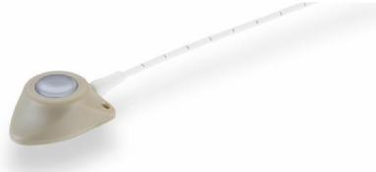
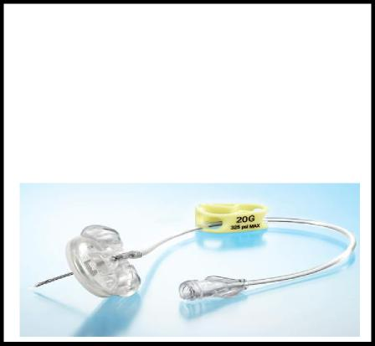
Port Access Needle¹
Implanted ports are accessed using a
special non-coring (Huber) needle

We would be most grateful if you could kindly provide the below information:
Information requested in respect of Implantable Ports
Question 1a Has your organisation purchased implantable ports between 1st April 2022 and 31st March 2023?
No
Question 2a If yes, to question 1a, please can you kindly provide a purchasing export report detailing the following relevant to implantable ports purchased between 1st April 2022 and 31st March 2023;
- Manufacturer
- Brand
- Product Code
- Description
- Volume (in pieces)
- Supply route for example, Direct, NHS Supply Chain etc

N/A
1 Lister, S et al, Royal Marsden Manual of Clinical Nursing Procedures, 2020, Chapter 17, Vascular Access Devices: Insertion and Management, page 1102

Question 3a Which clinical area(s) insert implantable ports in your organisation?
N/A
Question 4a Has your organisation any data regarding the number of patients that had a port inserted between 1st April 2022 and 31st March 2023 that also required a high-pressure injection contrast media scan?
N/A
Information requested in respect of Port Access Needles
Question 1b Has your organization purchased port access needles between 1st April 2022 and 31st March 2023?
Yes
Question 2b If yes, to question 1b, please can you kindly provide a purchasing export report detailing the following relevant to port access needles purchased between 1st April 2022 and 31st March 2023;
- Manufacturer
- Brand
- Product Code
- Description
- Volume (in pieces)
- Supply route for example, Direct, NHS Supply Chain etc

NPC | Description | Brand | MPC | UOI
FSQ2074 | Safety needle huber - connection line without y injection site 22g x 15mm extension 180 mm | Bard | LH0035 | 25
FSY351 | Safety needle huber - connection line with y injection site EZ Huber needle 22g x 25 mm with Y-site | PFM Medical UK Ltd | SHG22-100Y | 25
FSY355 | Safety needle huber - connection line without y injection site EZ Huber needle 22g x 19 mm | PFM Medical UK Ltd | SHG22-75 | 25
FSY360 | Safety needle huber - connection line without y injection site 22g x 15mm extension 180 mm | PFM Medical UK Ltd | SHN22-60 | 25

Question 3b Which clinical area(s) use port access needles in your organisation?
Jefferson Ward.
Thank you in advance for providing this information.

